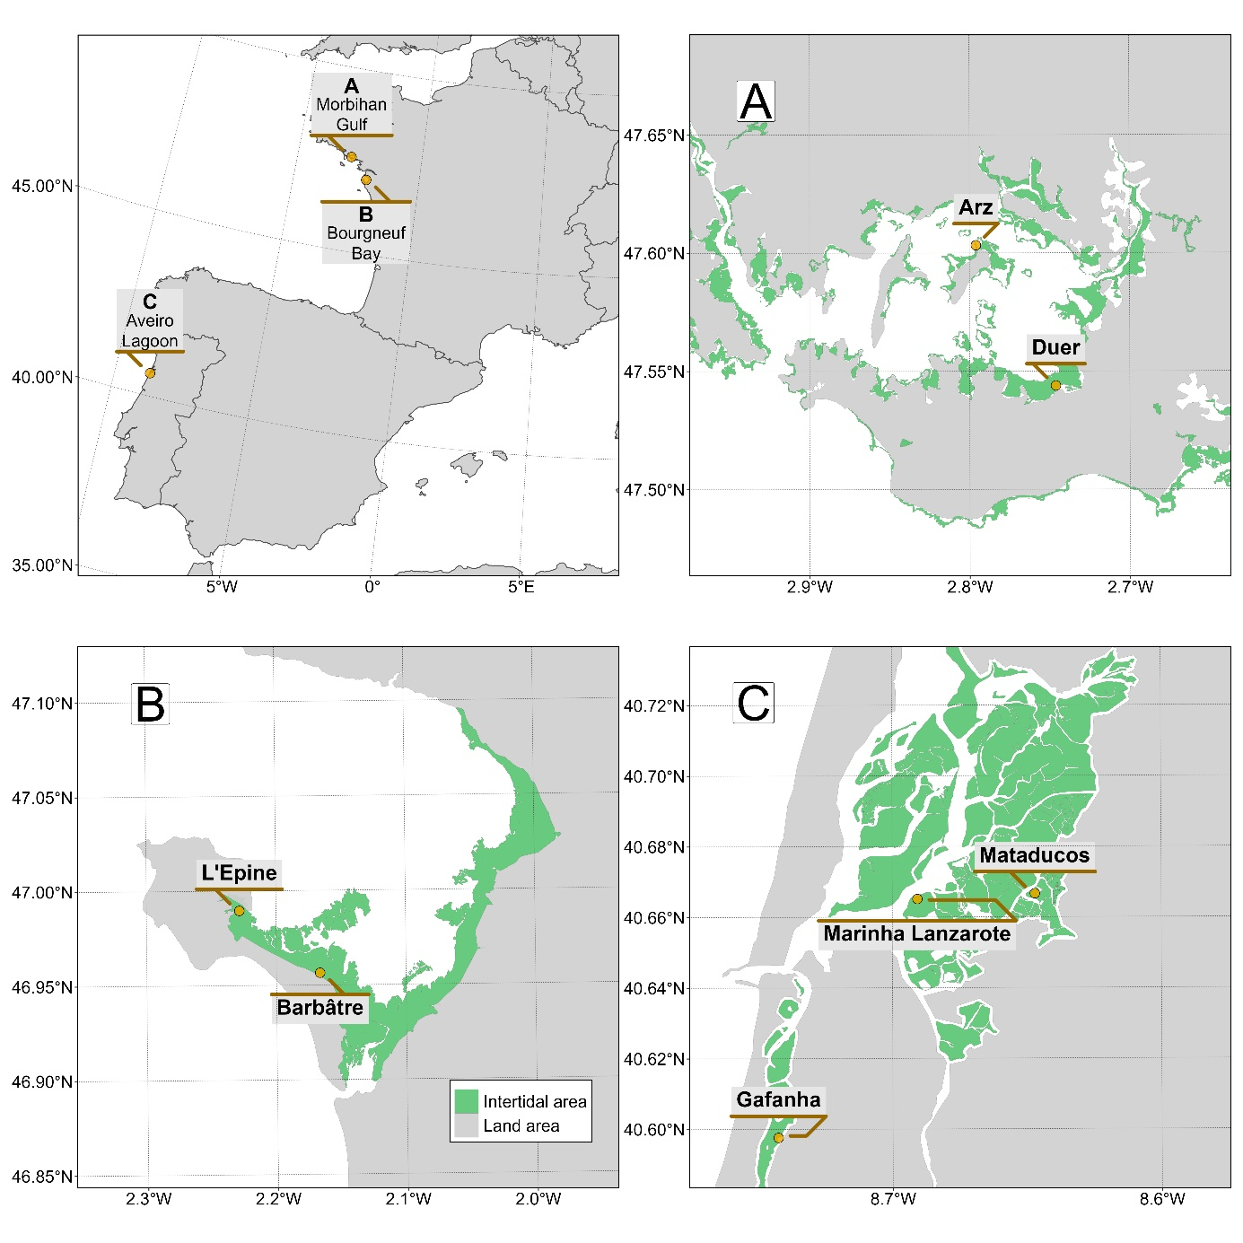Figure 1: Location of drone flights in France and Portugal. A: Gulf of Morbihan (Two sites), B: Bourngeuf Bay (Two sites), C: Ria de Aveiro Coastal Lagoon (Three sites). Green areas represents the intertidal zone.

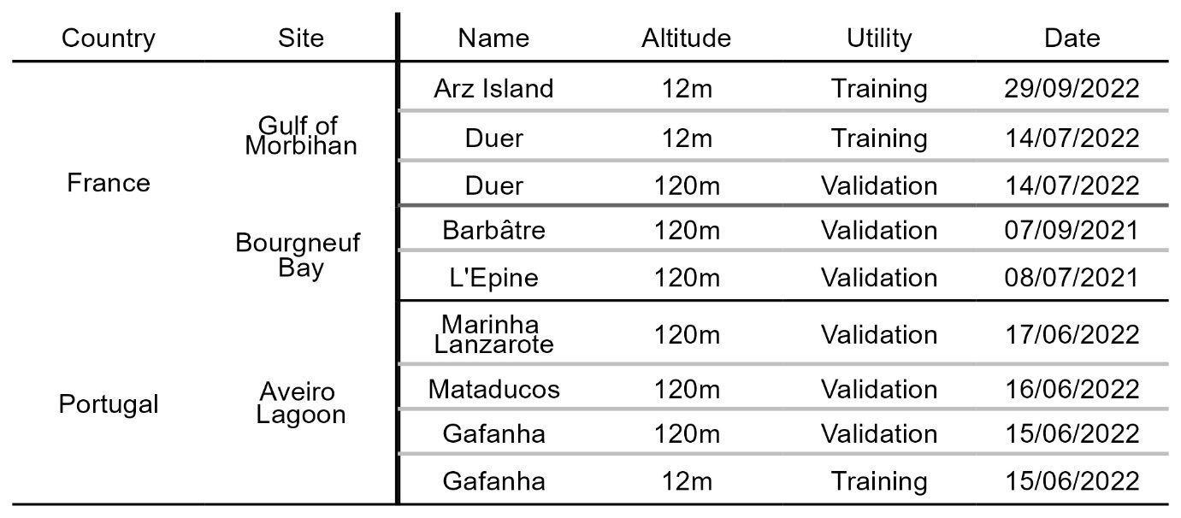Table 1 : List of drone flight, summarizing the date, the altitude, and the purpose of each flight. 12 m and 120 m flights have a spatial resolution of 8 and 80 mm respectively.

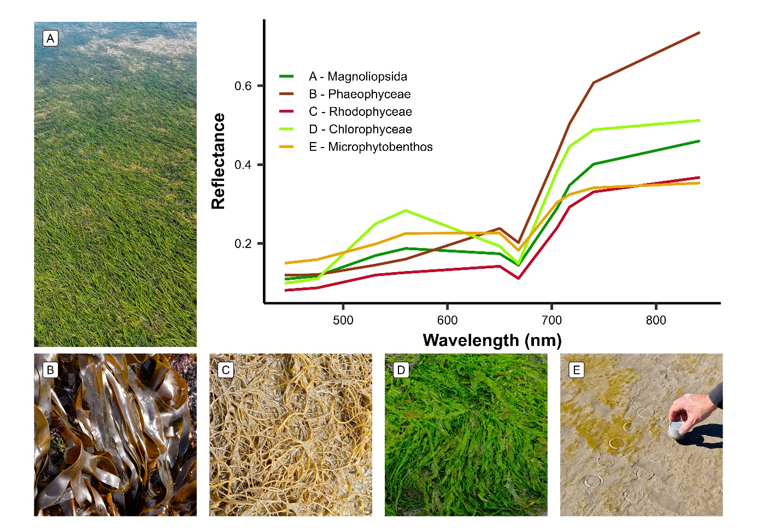Figure 2: The five taxonomic classes of vegetation used to train the Neural Network model and their raw spectral signatures at the spectral resolution of the Micasense RedEdge Dual MX. A : Magnoliopsida (Nanozostera noltei syn. Zostera noltei) ; B : Phaeophyceae (Fucus sp.) ; C : Rhodophyceae (Gracilaria vermiculophylla) ; D : Chlorophyceae (Ulva sp.) ; E : Bacillariophyceae (Diatoms - MPB)

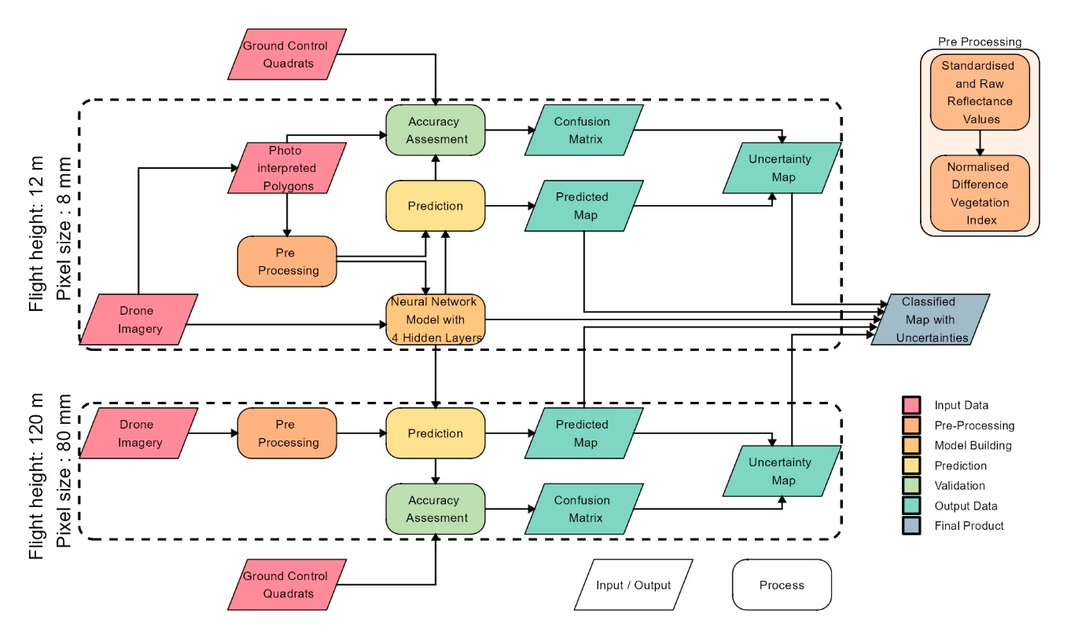Figure 3: Schematic representation of the workflow. Parallelograms represent input or output data, and rectangles represent Python processing algorithms. The overall workflow of this study is divided into two distinct parts based on the spatial resolution of the drone flights: high-resolution flights (pixel size: 8 mm) were utilized for training and prediction of the Neural Network model, whereas lower-resolution flights (pixel size: 80 mm) were solely employed for prediction purposes. Validation has been performed on both high and low resolution flights.

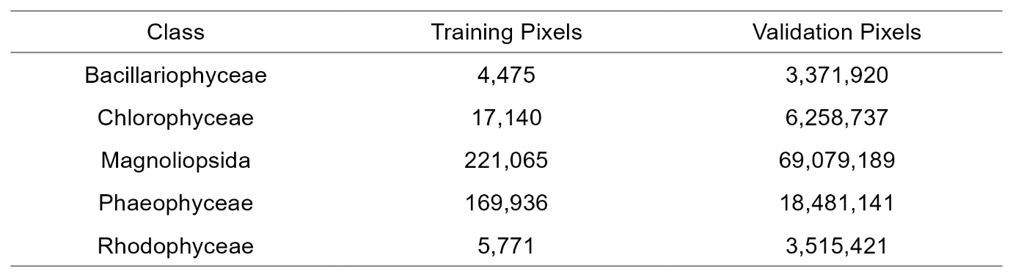Table 2: Vegetation Classes of the model and the number of pixels used to train and validate each class

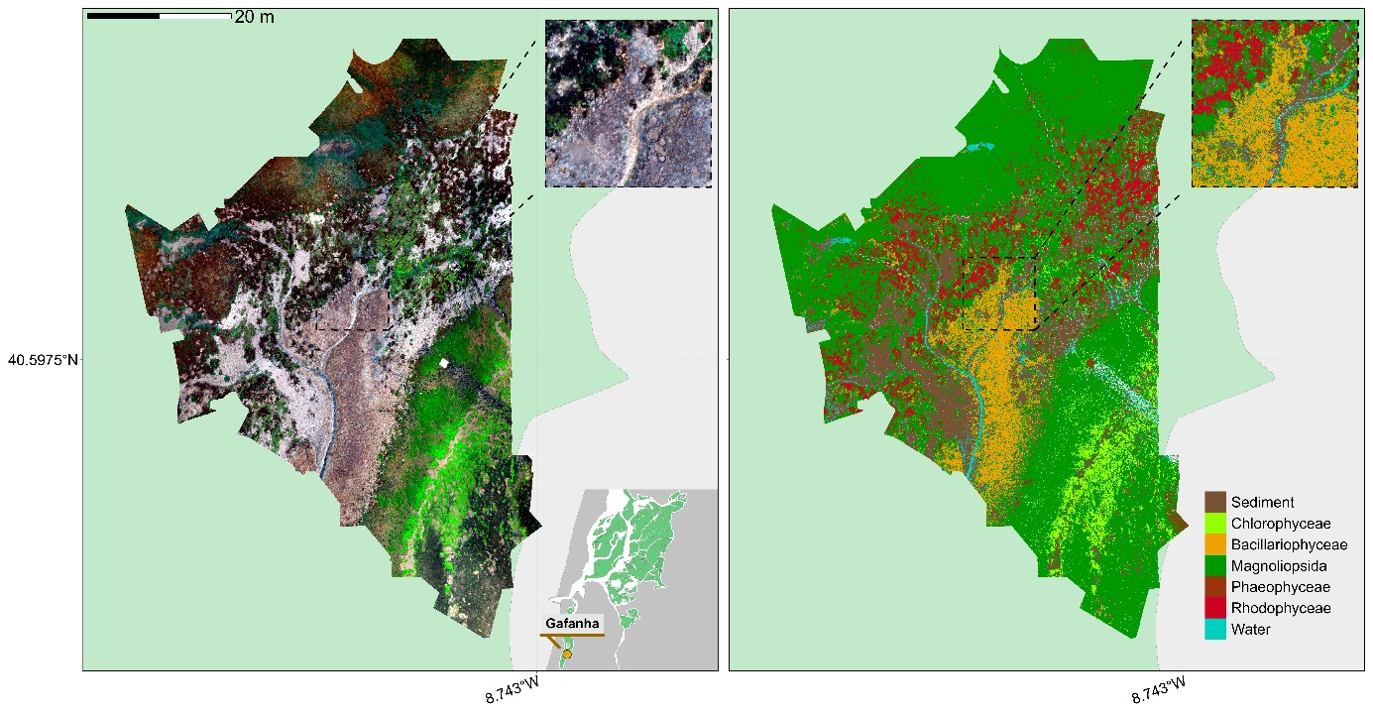Figure 4: RGB orthomosaic (Left) and Prediction (Right) of the low altitude flight of Gafanha, Portugal. The total extent of this flight was 3000 m² with a resolution of 8 mm per pixel. Background colors indicate intertidal area (Light Green) and land area (Light Grey). The zoom covers an area equivalent to a 10-meter Sentinel-2 pixel size.

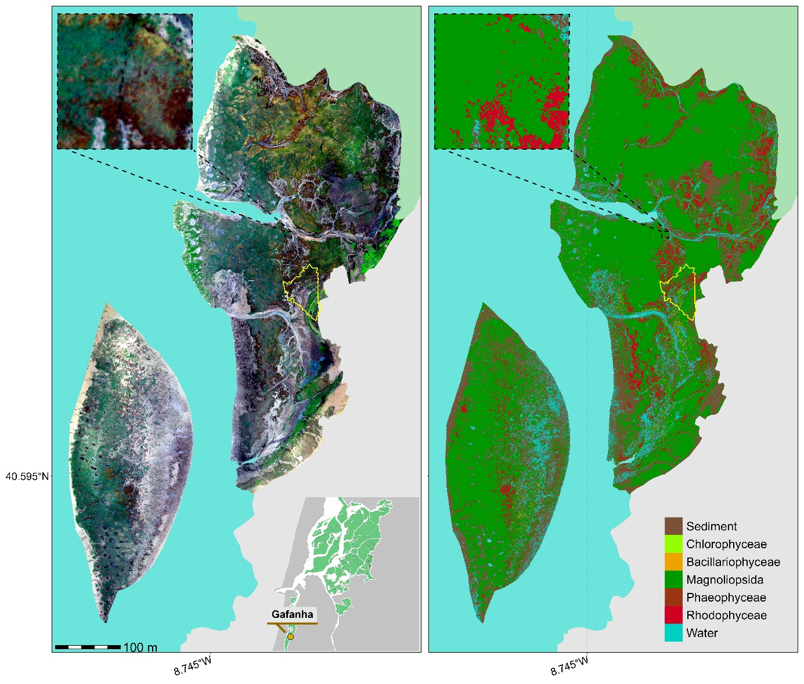

Figure 5: RGB orthomosaic (Left) and Prediction (Right) of the high altitude flight of Gafanha, Portugal. The total extent of this flight was about 1 km² with a resolution of 80 mm per pixel. Background colors indicate intertidal area (Light Green), land area (Light Grey) and water (Light Blue). The yellow outline shows the extent of the low altitude flight of Gafanha presented in Figure 4. The zoom covers an area equivalent to a 10-meter Sentinel-2 pixel size.

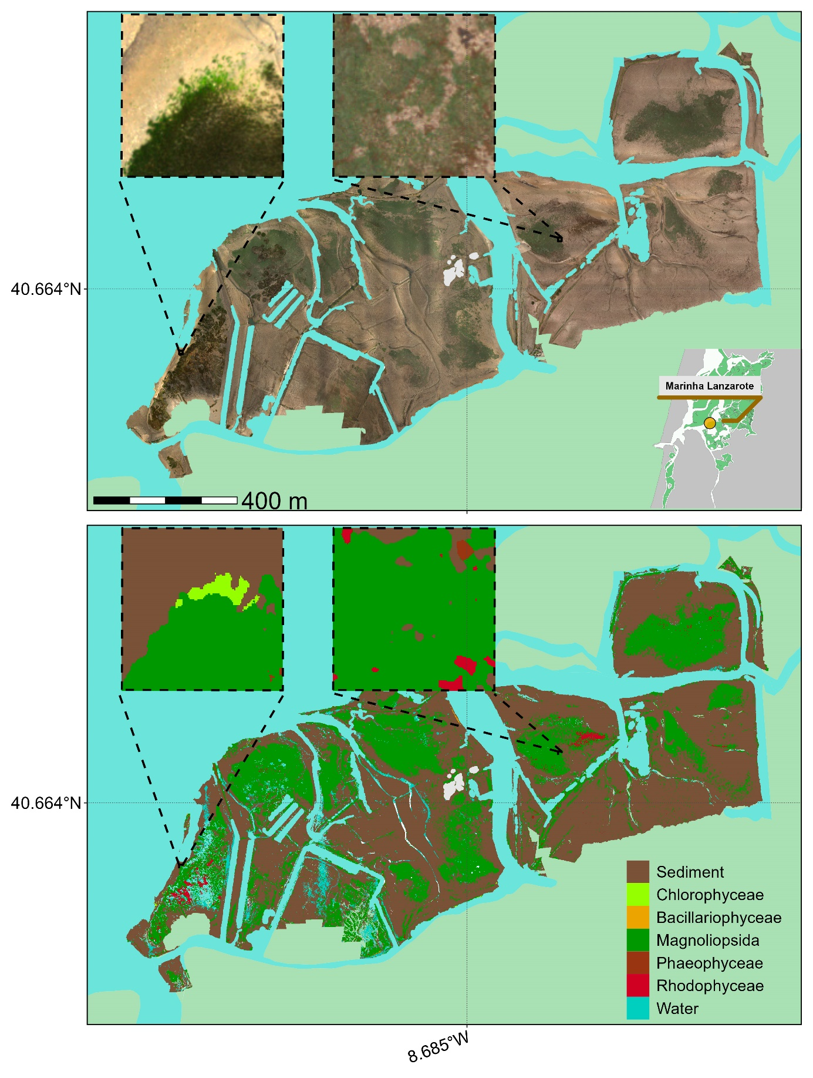

Figure 6: RGB orthomosaic (Top) and Prediction (Bottom) of the flight made in the inner part of Ria de Aveiro Lagoon, Portugal. The total extent of this flight was about 1.5 km² with a resolution of 80 mm per pixel. Background colors indicate intertidal area (Light Green), land area (Light Grey) and water (Light Blue). Each cover an area equivalent to a 10 m Sentinel-2 pixel size.

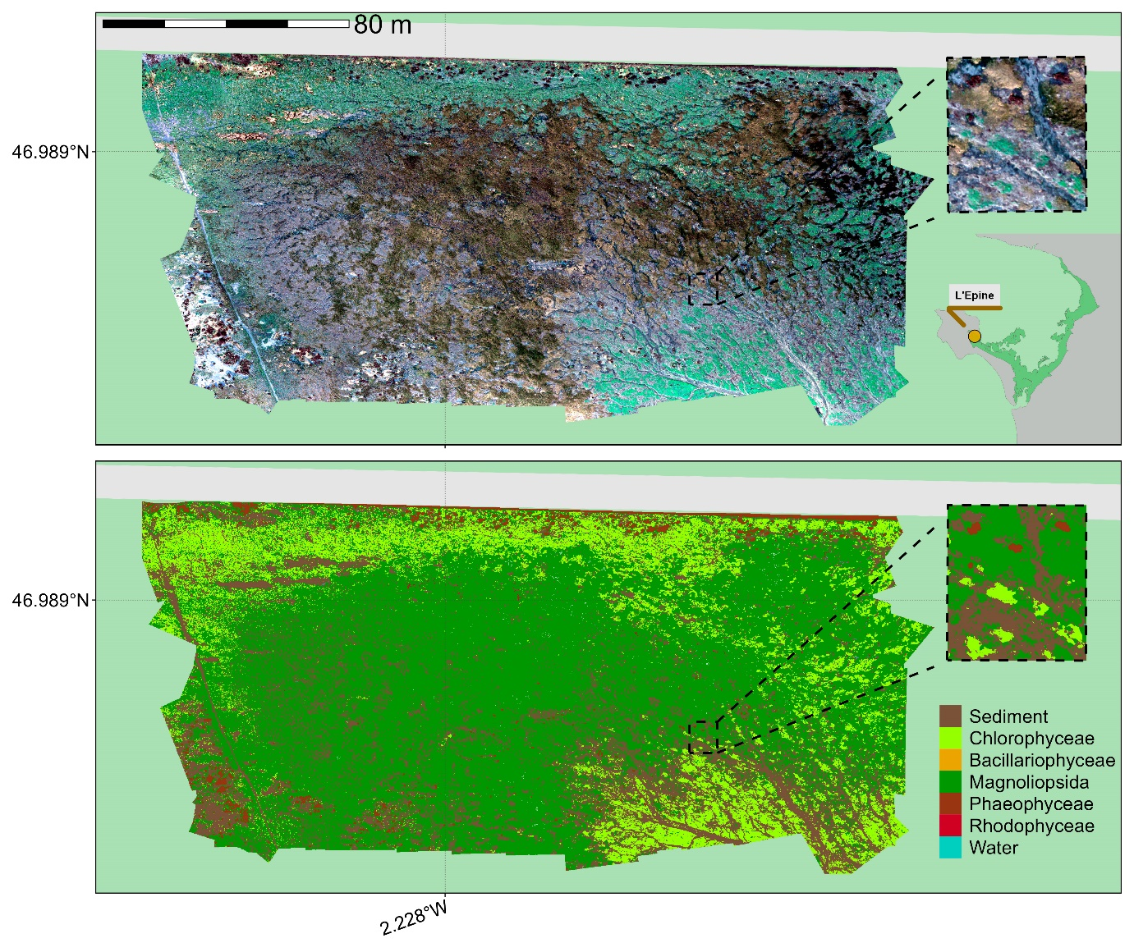Figure 7: RGB orthomosaic (Top) and Prediction (Bottom) of L’Epine, France. The total extent of this flight was about 28 000 m² with a resolution of 80 mm per pixel. Background colors indicate intertidal area (Light Green) and land area (Light Grey). The zoom covers an area equivalent to a 10-meter Sentinel-2 pixel size.

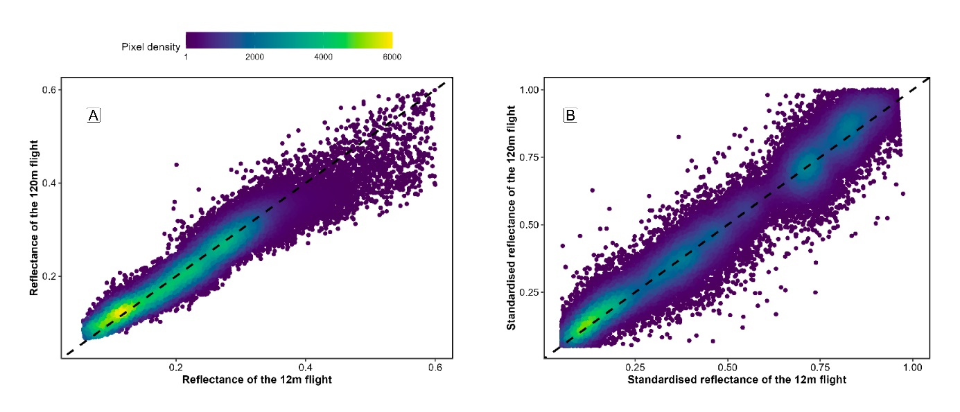

Figure 8: Comparison of reflectance retrieved from both low-altitude and high-altitude flights over a common area. The black dashed line represents a 1 to 1 relationship. Left (A) plots raw data and right (B) plots standardized data (Equation 1).

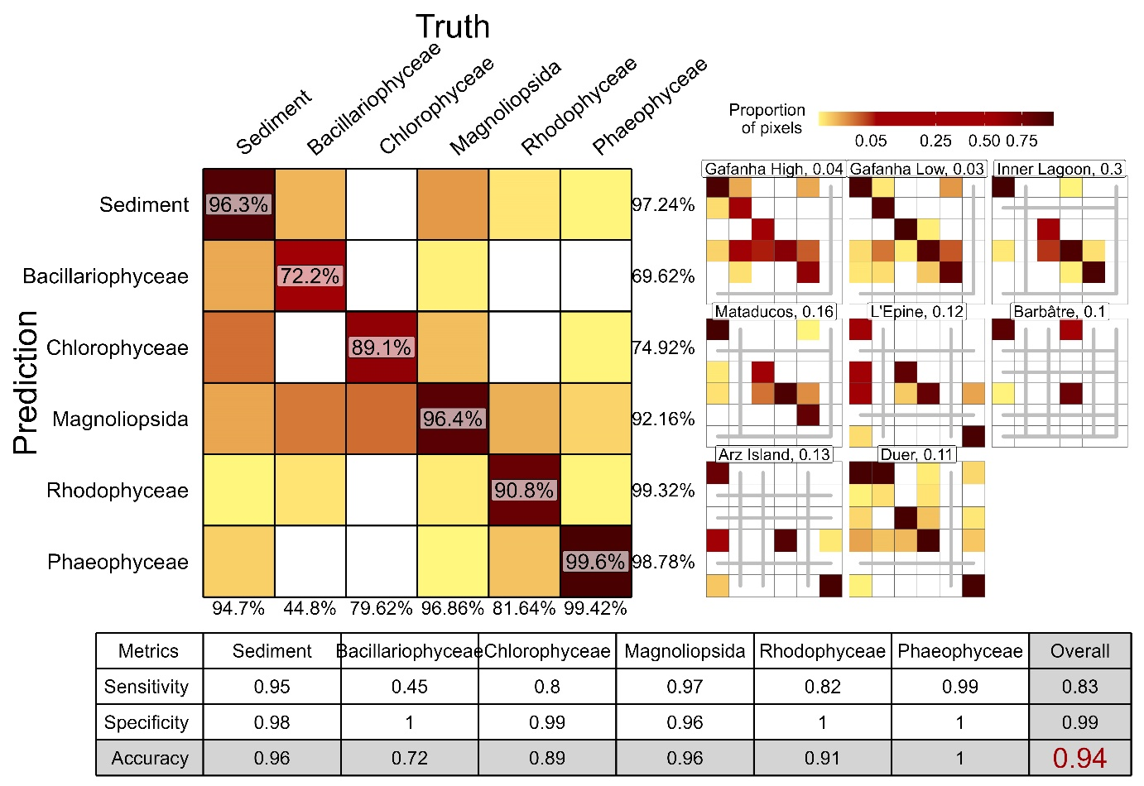

Figure 9: A global confusion matrix on the left is derived from validation data across each flight, while a mosaic of confusion matrices from individual flights is presented on the right. The labels inside the matrices indicate the balanced accuracy for each class. The labels at the bottom of the global matrix indicate the User’s accuracy for each class, and those on the right indicate the Producer’s Accuracy. The values adjacent to the names of each site represent the proportion of total pixels from that site contributing to the overall matrix. Grey lines within the mosaic indicate the absence of validation data for the class at that site. The table at the bottom summarizes the Sensitivity, Specificity, and Accuracy for each class and for the overall model.

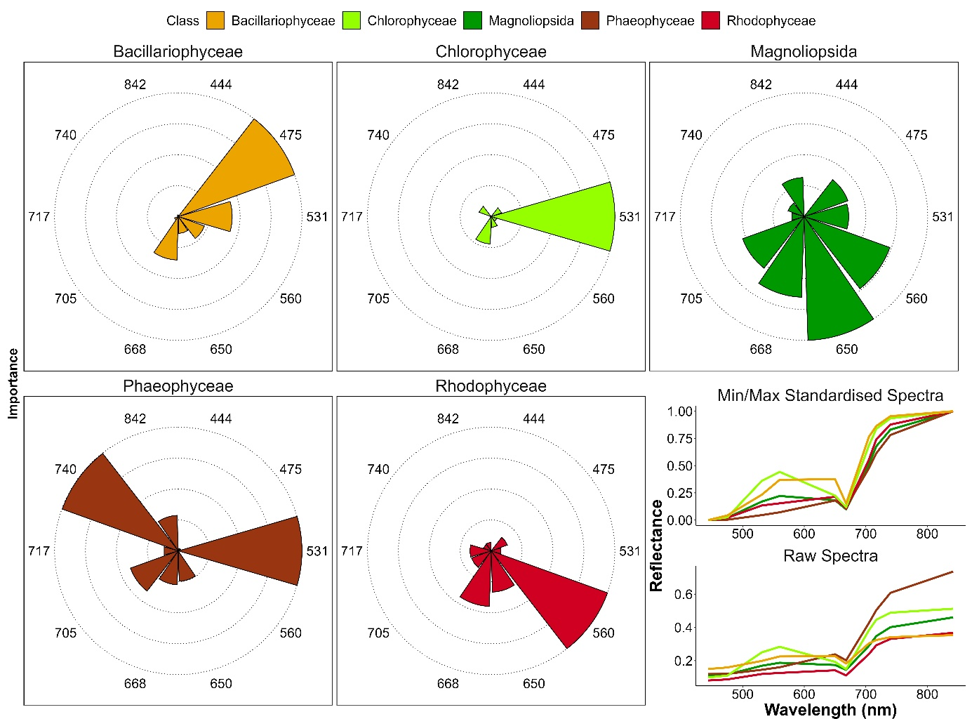

Figure 10: Variable Importance of the Neural Network Classifier for each taxonomic class. The longer the slice, the more important the variable for prediction of each class. The right plot shows the drone raw and standardised reflectance spectra of each class. Each slice represents the Variable Importance (VI) of both raw and standardised reflectance combined.

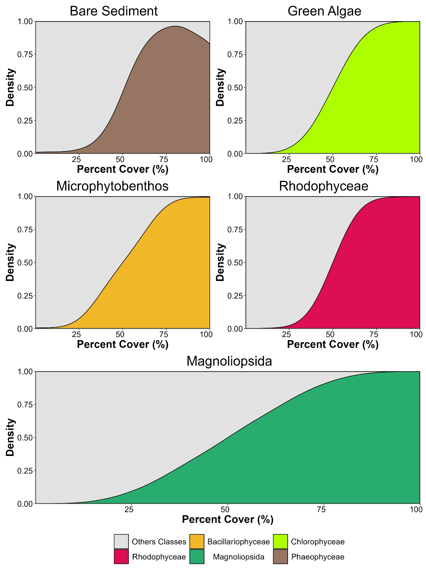Figure 11: Kernel density plot showing the proportion of pixel well classified based on the percent cover of the class in high altitude flight pixels of Gafanha, Portugal. Each subplot shows all the pixels of the same classes on the high altitude flight. Percent cover of classes was retrieved using the result of the classification of the low altitude flight of Gafanha, Portugal.

Figure 12: Photosynthetic and carotenoid pigments present (Green) or absent (Red) in each taxonomic class present in the Neural Network Classifier, along with their absorption wavelength measured with spectroradiometer. Chl-b: chlorophyll-b, Chl-c: chlorophyll-c, Fuco: fucoxanthin, Zea: zeaxanthin, Diad: diadinoxanthin, Lut: lutein, Neo: neoxanthin, PE: phycoerythrin, PC: phycocyanin.

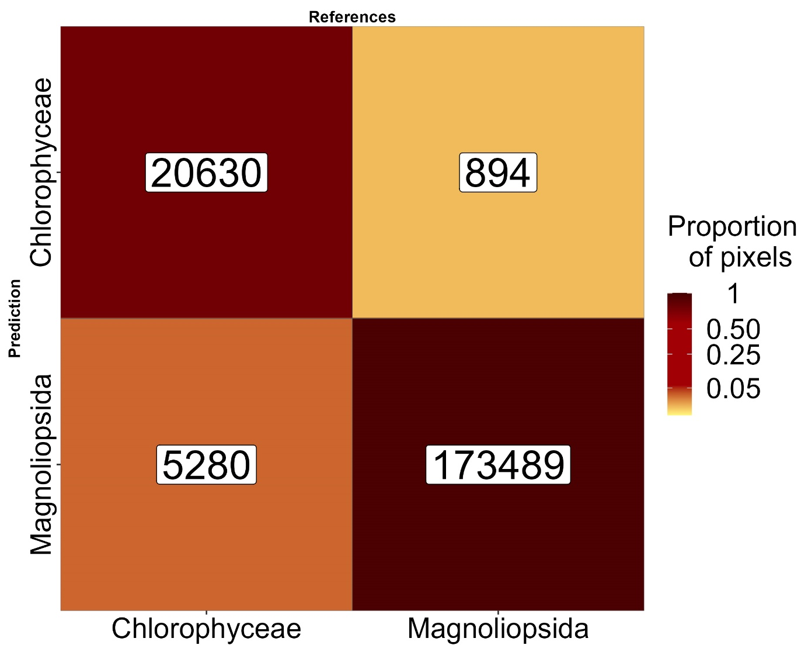

Figure 13: Sample of Figure 9 focusing on green macrophytes. The labels inside the matrix indicate the number of pixels.